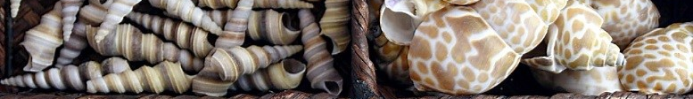
Cabinet Of Curiosities: A Hands-On History Of Wonder
The following activities are designed to supplement a visit to the exhibit. Collections of extraordinary natural and manmade objects were displayed in cabinets with many compartments, each filled with “treasures”. Come explore and interact with thousands of artifacts and specimens in the Cabinet of Curiosities: A Hands-on History of Wonder.
Curate a Cabinet (onsite activity)
Materials: Copy of blank cabinet template; pencil
First, take time to explore the room. Open the drawers and discover what’s inside. On the cabinet of curiosity template, number each of the squares from 1-9 in the upper left-hand corner of each. Next, locate objects that match the following descriptions and sketch it in the appropriate box; include a short description.
- A taxidermied animal
- A weapon
- Jewelry
- A shell
- A fossil
- Pottery
- A mask
- An insect
- An egg
Curate a Cabinet (classroom activity)
Materials: Copy of blank cabinet template; pencil, magazines or internet access, glue, scissors; example cabinet of curiosity with pictures
Discuss how museums exist to inspire people to wonder and to facilitate creative thought and how our curious natures and our innate desire to collect inspired the modern museum. Explain that museums began by the institutionalization of privately-owned collections of extraordinary objects from the past. These collections were called cabinets of curiosity and first became popular in the Renaissance and reached their pinnacle of popularity in the Victorian Era.
Discuss what one might find in a cabinet of curiosity. Allow student to research the history of the phenomenon to come up with ideas of what kind of interesting objects were in some of the more famous collections.
Show the class the example of the cabinet of curiosity with pictures. Distribute a blank cabinet template to each student. Encourage students to find appropriate pictures in magazines or on the internet to cut and paste into the nooks on the cabinet page. Students should be encouraged to “collect” pictures of both man-made and items from nature. The student may add their name in the tag at the bottom of the sheet. Students will then share their collections with the class.
Curate a Classroom Cabinet of Curiosity (classroom activity)
Who doesn’t love show-and-tell? All students, from preschoolers to high schoolers still love to show off prized items to their friends. Capitalize on this propensity to share while examining the motives of students and collectors of the past for curtaining collections of objects. After completing the above activities, encourage students to bring in objects to share with the class. Students can then collaborate to create a classroom cabinet of curiosity to display these items. Planning, collecting, and curating a cabinet of their own will enable students to find a place for themselves within the larger and older tradition of collecting, curating, and displaying fascinating objects for intellectual pursuits.

